Notes:
The author had less than 24 hours to put this document together for Director-level review. AWS Security and IT Services leadership accepted all but one of the recommendations. “Security key password” had to be changed to “security key PIN” for password compliance reasons. Other than that, these changes were approved and implemented throughout the security key experience and in IT setup instructions June 2020.

“Given the way the review went, I wouldn’t change the doc much,” the author says. “I’m sure there are plenty of ways it can be improved, but the argument and justification we made for the necessity of the change was sufficient to gain alignment so I’m happy with it.”

Doc Bar Raiser Thoughts:
What did the doc do well?
- The document follows a logical structure. It lays out a clear objective, the current state/pain points, and the proposed changes with feedback from a partner team.
- The document presents a data-driven, customer-centric argument for change. In the current state section, the author lays out feedback from new hires, data on the number of IT contacts about these issues, and ratings from the IT site to back up the need for a new approach.
- The document does not shy away from disagreement. The author represents feedback from a partner team fairly, bringing them into the process with direct quotes incorporated for each proposed change.
- The document presents clear next steps with dates.

Where could the doc develop further?
- Appendices A and B have small x/y axes that are hard to read.
- Seven sentences on the first page are over 30 words. The author can improve readability by breaking up or simplifying these sentences. Example of a long sentence: “We recommend reserving the term Midway for further technical documentation that details how the process works, or in scenarios where it’s required to differentiate between the requirements for using different authentication services (e.g. Federate vs. Midway).”

Overview
The purpose of this document is to gain alignment with IT Services and AWS Security on proposed changes to the customer-facing language that is used to describe how Amazonians securely access the Amazon network. The goal of these language changes is to reduce customer confusion and IT Support tickets by simplifying and standardizing authentication content.

Current state
Today, the customer experience is inconsistent through each step of the authentication process. Different teams own different portions of the process, and customers—particularly new hires—have trouble learning how to register, use, and troubleshoot issues around authentication.
New hires have to learn about USB security keys that are referred to as tokens in their Midway dashboard, setting a Midway PIN, registering or revoking or unregistering a USB security key or token, and signing in with Midway to access the Amazon VPN and their Midway dashboard. The connection between USB security keys, Amazon VPN, and Midway isn’t intuitive. It contributes to the steep Day 1 learning curve.
In January 2020, interviews with 106 new hires at a Seattle new hire fair revealed that 34% of them reported that USB security key-related issues were a blocker to their onboarding process. Of these, 27% were confused by how their security keys work and when to use them. 25% were confused by the instructions and the different terms that are used for describing the same thing, and 16% didn’t realize on Day 1 that they needed 2 separate passwords.
Four of the top five lowest-rated articles on it.amazon.com are related to Midway. In the trailing 4 weeks, 9% of contacts to IT Support were driven by Midway-related issues. On the highest day, Midway-related issues accounted for 12% of total contacts, making it one of the top ten contacts drivers. See Appendix A.
New hires account for the majority of Midway-related contacts. Security key registration issues and PIN issues are the most common reasons for contacts from new hires, with the majority of these contacts happening on Mondays—Day 1 for these new hires. See Appendix B.
From this data, we learn that there’s room for improvement in the way we educate and talk about authentication. Standardizing and simplifying content is one way to reduce the number of TTs relating to Midway, while improving the new hire experience. There is a separate work stream to identify inefficiencies in the process that will be presented in detail in the near future.

Proposed changes
The following high-level content recommendations streamline the language throughout the authentication experience. By simplifying the language we use, we make the security key process more intuitive. Customers use a security key password with their security key, and visit their security key dashboard to make necessary changes. All of the terms match, reducing cognitive friction points. We recommend standardizing and applying this to sign-in pages, within the Midway dashboard, in emails, in FAQs, and in it.amazon.com and technical documentation.

Lead with Security key, but do not remove Midway
The term “security key” is the primary term we use when referring to the authentication process. We recommend reserving the term Midway for further technical documentation that details how the process works, or in scenarios where it’s required to differentiate between the requirements for using different authentication services (e.g. Federate vs. Midway). Examples of the practical application of this recommendation include:
- For TT and IT Support categorization, issues relating to Midway can be relabeled as either security key issues or security key login issues.
- To register your security key, visit the “Security key dashboard.” To explain why Midway is part of the URL on the security key sign in page, that page would include one sentence explaining that Midway is the name of the service that provides secure access to the Amazon VPN.
By minimizing the term Midway in customer-facing content, we reduce the number of Amazon-specific terms relating to the process of signing in to the Amazon VPN.
Midway team feedback: We disagree with the suggestion of using Midway only in technical documentation. We want to call thing by their proper name, just like we talk about Chrome and Firefox and Edge (and not say browser). A Midway key is something used by the Midway system. Users register their Midway key at midway.amazon.com and sign in at midway-auth.amazon.com. When they contact IT support, it is because they cannot sign into Midway. The meaning is precise.

Midway PIN
We recommend changing Midway PIN to security key password. In a May 2020 survey of 18 Seattle-based Amazon new hires, 56% said that Midway PIN doesn’t accurately describe this login requirement. 44% said that security key password would be a clearer description than Midway PIN, and 33% said that Midway password was the clearest option. Only 17% selected Midway PIN as the clearest option. See Appendix C for more detail.
Midway team feedback: We disagree with the suggestion of calling it “security key password”. It is a PIN, not a password. Passwords generally have to be rotated and have a certain complexity requirement. Calling something a password may have compliance implications, forcing us as a company to rotate passwords. According to Wikipedia, a PIN can have alphanumeric characters. PINs are long lived without rotation and are less complex than passwords. The PIN is for the Midway system, not for the Midway key, i.e. technically, the PIN does not unlock the key. We suggest we do not use an incorrect technical term.

Midway token, USB security token, USB security key, Zukey, YubiKey
We recommend standardizing the way we refer to this hardware and referring to all of them as security keys. Amazon uses security keys in a variety of formats. Calling all of them by one name—security keys—simplifies the customer experience.
A concern was raised in the 11-May stakeholder review meeting that security keys might be a redundant term with Data Center (DC) or Sensitive Compartmented Information Facility (SCIF) equipment. We reached out to a DC contact (sphllp@), who said that to the best of his knowledge there is no DC or SCIF equipment by that name.
Technical documentation can be an exception to this in situations where distinguishing between the different types of security keys is necessary.
The other exception to this is Federal Information Processing Standard (FIPS) security keys, which should be referred to as FIPS security keys.
Midway team feedback: We disagree with the suggestion of calling it “security key”. We agree we should stop using the term tokens, Yubikeys, Zukeys, etc. Start using Midway key everywhere. We used to have RSA tokens and Gemalto tokens, and now we have Midway keys. We may have something new in the future, which should have a name that can easily distinguish it from anything that used to exist. Specific names give things precise meaning. Especially in a transition, calling things by their proper name helps.

Midway dashboard
Our recommendation is to lead with security key dashboard. We recommend using the term Midway to describe the authentication process in technical documentation, but the purpose of the dashboard is not to detail the authentication process. Its primary purpose is for Amazonians to register and manage their security keys.
The goal of simplifying this language is to decrease customer confusion and contacts. Removing Midway from the name of the dashboard would make the name of the dashboard correlate with the primary way a customer will use it.

Authenticate or authentication
We recommend changing this to sign in with your security key password and security key. While authentication is technically correct, there’s an opportunity for customers who aren’t familiar with that technical term to be confused by it. Sign in is a common everyday phrase that’s less likely to confuse customers.
Technical documentation can be an exception to this in situations where it’s necessary to use the technical term for the process.
Midway team feedback: We agree to use “Register/Unregister” and “Sign in” instead of authenticate. We agree the term MFA should not be used except in technical documentation.

Next steps
4-May – Present proposed language changes to Midway team.
11-May – Review feedback from the Midway team on the proposed changes.
14-May – Review feedback from the IT Services knowledge base and comms team and Midway team. Finalize and approve language recommendations.
20-May – Leadership review of proposed changes and working backwards timeline to complete language refresh across UX, communications, and it.amazon.com articles.
21-May – Share changes with AWS Digital Identity team and determine targeted date for changes.
27-May – IT Services comms team provides revised Midway emails with approved Midway language to Midway team.
27-May - IT Services comms team provides revised FIPS emails and wiki page with approved language to FIPS team.
TBD – Need a date from Midway team on when changes to Midway owned pages can be updated.
Stakeholders
Names and titles listed here

Appendices

Appendix A
Midway contacts to IT Support

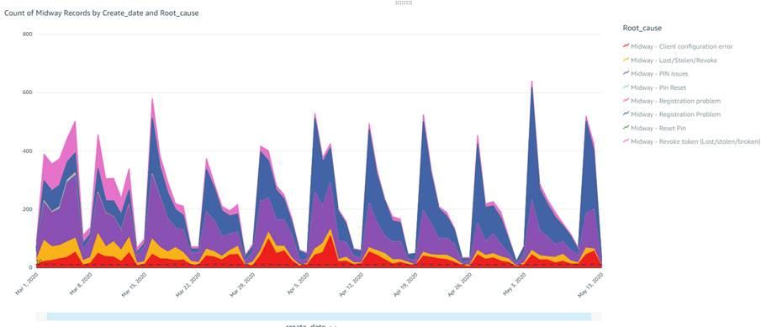

Appendix B
Spikes in Midway contacts. Large WoW spike (GREEN) are Mondays when New Hires start.

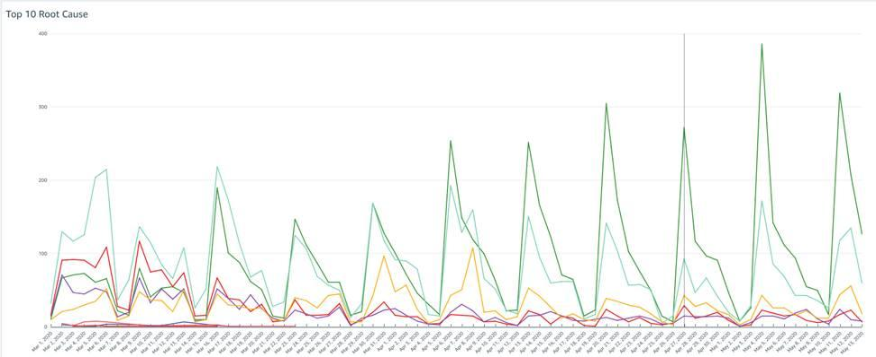

Appendix C - May 2020 survey of 18 Seattle-based Amazon new hires
Total Surveyed | 18
When signing in to the Amazon network, does *Midway PIN* accurately describe what you have to type in before you press and hold your USB security key? | Total | %
Yes | 6 | 33%
No | 10 | 56%
Not Sure | 2 | 11%
Would describing your *Midway PIN* as your *Midway password* make the process more, less, or equally clear? | Total | %
They seem equally clear to me. | 4 | 22%
Describing it as a Midway password would be more clear. | 8 | 44%
Describing it as a Midway password would be less clear | 5 | 28%
I'm not sure. | 1 | 6%
Would describing your *Midway PIN* as your *security key password* make the process more, less, or equally clear? | Total | %
Describing it as a security key password would be more clear. | 8 | 44%
Describing it as a security key password would be less clear. | 7 | 39%
They seem equally clear to me. | 2 | 11%
I'm not sure. | 1 | 6%
Which one is the clearest option? | Total | %
Security key password | 8 | 44%
Midway password | 6 | 33%
Midway PIN | 3 | 17%
None of the above | 1 | 6%
We're working on a new security key option and would love your opinion. This security key option doesn't require a physical security key. Instead, an app on your phone would provide a random 6-digit passcode that you would enter to sign in to the Amazon network.  Which, if any, of these options do you prefer for describing this random 6-digit passcode? | Total | %
1-time code | 4 | 22%
2-way verification code | 5 | 28%
Virtual security key | 4 | 22%
Soft security key | 2 | 11%
Soft OTP | 3 | 17%

New Hire Fair January 2020 interviews data.
1) Reset Midway PIN, 2) Connect to VPN, 3) Register a USB security key 4) Security keys.

